**Cybersecurity – Jesse Ijiwola**

**Activity 4.1.4 Steganography**

**Hidden Writing:**

With all of these historical examples of writing, what are the limitations?

**Your Answer: Computer algorithms could quickly discover patterns and find the hidden data and messages and keys could be discovered by outsiders.**

**Substitution Steganography:**

In your own words, explain how substitution steganography works to hide a message inside of an image.

***Your Answer: By changing the last bit in parts of an image, you can modify images to look the same to the human eye but entirely different which can only be discovered through computer algorithms***

Although it was not discussed - think) how could the same principle be used to hide a message in an MP3 file which is used to store music/audio data.

***Your Answer: you could change the pitch of the audio unable to be hear by the human ear to hide data.***

**Insertion Steganography:**

Overview - you will create a Windows text file and store the text “hello world” in that file - then you will write ADS data, the text - “hidden data” into the ADS stream which is attached to the file but as you will see it will not show.

6) At this point what is the file size:

***Your Answer: 14 bytes***

8) Be very careful typing the command - notice you are using the less than sign not greater than sign this time!

9) Use screen shots to document your work for this step (including the file text and the ADS data):  
***Your Screen Shots:***

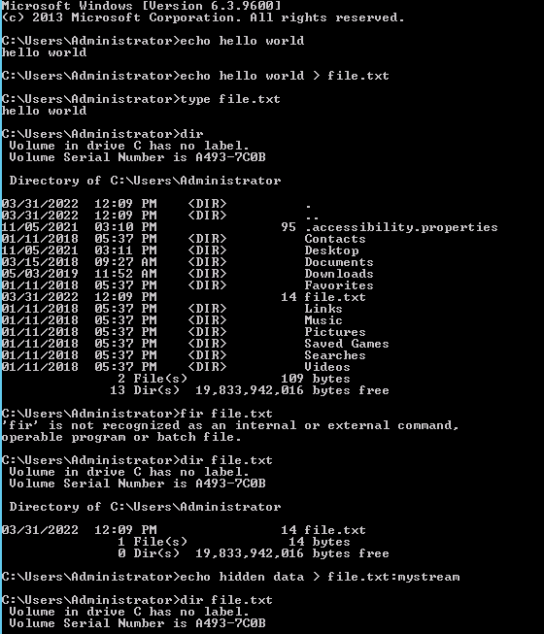

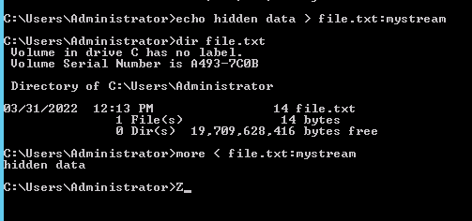

***Pay attention to the narrative under step #9 - important info!***

10) Screen shoot your results of this step:  
***Your Screen Shot:***

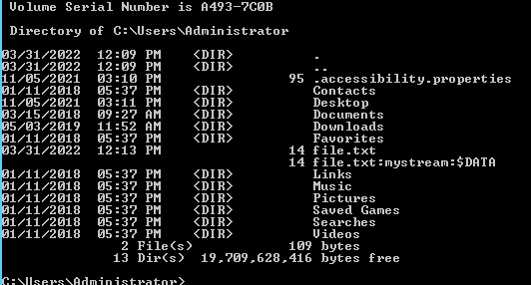

**Generation Steganography:**

For this section - you will send and receive a message to yourself.

12) Screen shoot your message being encoded:

***Your Screen Shot:***

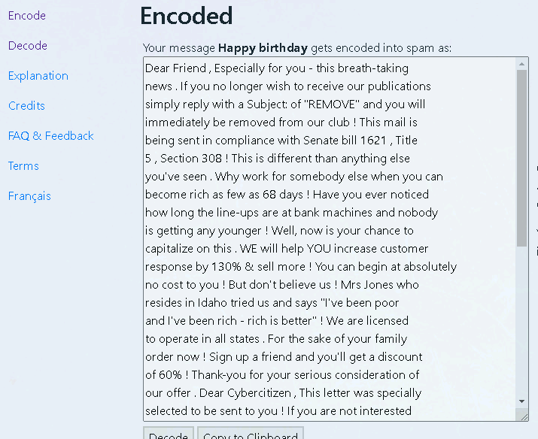

12) Screen shoot your message being decoded:

***Your Screen Shot:***

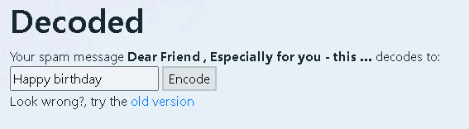

14) Decode the original message at the beginning of this section:

***The message decoded - Screen Shot:*** 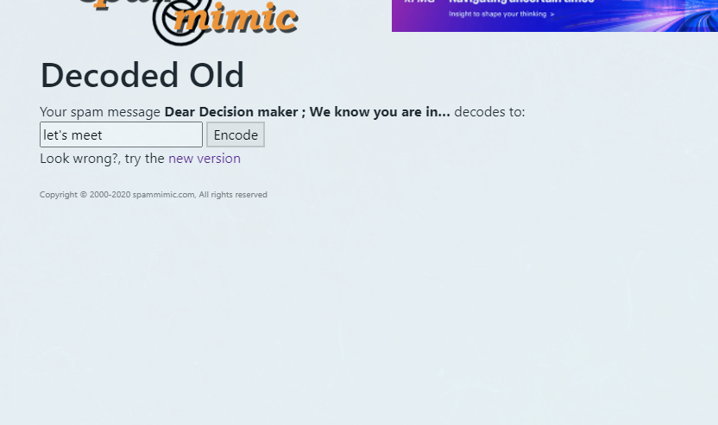

Would hiding a message in this manner be considered an overt OR covert form of steganography?

**Your answer: This would be considered overt because even if the message is seen it wouldn’t matter and isn’t related to the original message.**

**Digital Watermarking:**

After reviewing the table, summarize the key differences between digital watermarking and steganography.

***Your Answer: Digital watermarking uses a very small amount of data while steganography uses as much data as possible. Also, if digital watermarking is detected it isn’t critical to whatever the watermark was put on.***

If I were a professional photographer - which would I use (digital watermarking or steganography).

***Your Answer: Digital Watermarking***

If I were a Chinese dissident who did not agree with his government - which would I use to send messages?

***Your Answer: Steganography***

Uncover a Message:

16) Screen shoot your text message being created…

***Your Screen Shot:***

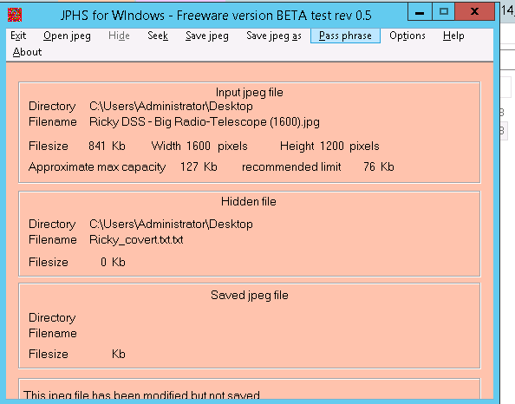

21c) Use **password** as your password to make things faster later…

21d) Screen shoot this step in the process…

***Your Screen Shot:***

